4. Solution Design
This section describes the design of the proposed solution that aims at providing a practical and controlled training platform for common AI-based cyber threats to Axiom, an AI-based cybersecurity training platform designed for InspireCyber. The proposed solution addresses the proposed architecture, technology stack, security measures, and cost of implementing the project. The proposed architecture has been intentionally designed in such a way that it can accommodate future growth requirements if needed.

4.1 Proposed Solution Architecture
The four key layers suggested for Axiom are the user interface, application backend, scenario engine, and database. Two roles are supported by the MVP – Learner and Administrator. The learners have an option to take part in cybersecurity scenarios from the perspective of the Red Team and/or the Blue Team. Administrators deal with scenario management and tracking learner progress.
A unique feature of the Axiom system is that it combines gamified cyber security training alongside simulated AI-based threats. Rather than just using awareness content, learners get to engage with simulations of phishing and prompt injection attacks and get points, track their progress, and get feedback. The use of fake emails, files, and chatbot conversations enables the training to be conducted without putting the actual organizational infrastructure at risk.

Figure 4.1: Proposed Axiom Solution Architecture
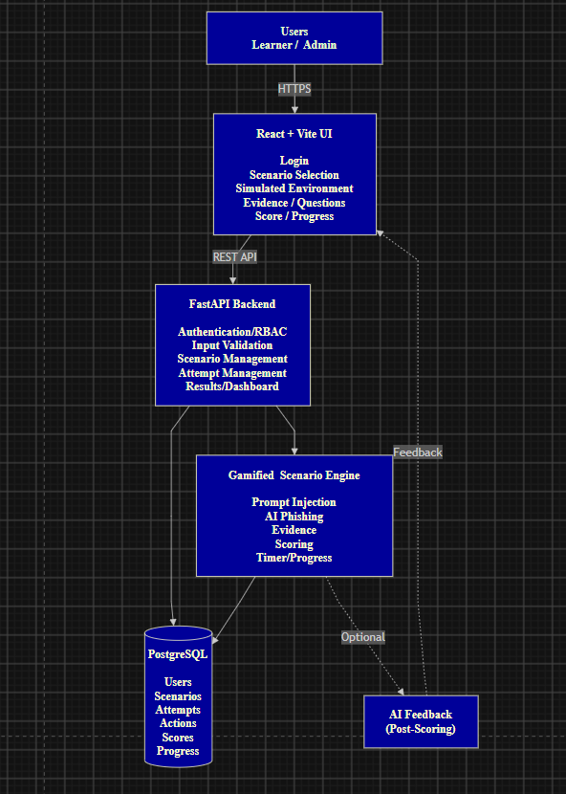
Fig 4.1: Axiom Architecture

Figure 4.1 describes the architectural design of Axiom. It comprises the React and Vite frontend, FastAPI backend, Scenario Engine, and PostgreSQL Database. Two types of users exist in the MVP namely the Learner and the Administrator. The backend takes care of authentication, access, validation, and communications between the interface, scenario engine, and the database.

The Scenario Engine takes care of prompt injection and the AI-phishing activities such as rules, questions, scoring, timer, and progress. Gamification features include the use of points, completion time, and progress tracking.

Axiom utilizes an environment that is simulated using fake emails, files, chatbot, and other evidences. As such, the learners can practice their cybersecurity skills in a safe environment without accessing any real organizational network. Scenario content is considered untrusted data to ensure no malicious data is interpreted as application commands.

Learner Scenario Workflow

The system architecture describes the technical design of Axiom, but the workflow below will demonstrate how a learner performs a gamified training task.

Figure 4.1.1: Axiom Learner Scenario Workflow 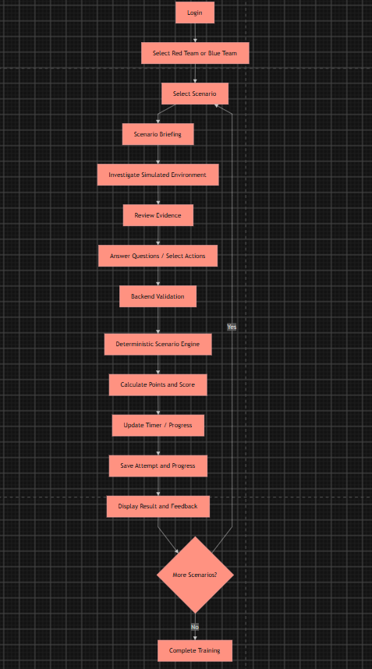
Fig 4.1.1: Axiom Learner Scenario Workflow

Figure 4.1.1 demonstrates the progression of the learner through the scenario. The learner will log in, select the team point of view as well as scenario, go through the briefing, examine the virtual environment, and respond to the questions or choose actions.

The back end will confirm the actions of the learner, while the Scenario Engine will compute the score, points, and progress. Finally, the attempt is saved, and the learner is provided with the result and feedback.

4.2 Technology Stack and Justification
The proposed technology stack was selected to meet Axiom's functional, security and scalability requirements while keeping the MVP simple to develop and maintain.
Component | Technology | Justification
Frontend | React + Vite | Supports interactive and reusable UI components
Styling | Tailwind CSS | Enables consistent and responsive design
Backend | Python + FastAPI | Lightweight API framework with validation support
Database | PostgreSQL | Suitable for structured user, scenario and result data
Authentication | JWT + RBAC | Provides authentication and role-based access
Scenario Engine | Python | Handles scenario rules and server-side scoring
AI | External LLM API, optional | Can provide learning feedback without controlling scores
Testing | Vitest, React Testing Library, Pytest | Supports frontend and backend testing
Version Control | Git + GitHub | Supports collaboration, branching and pull requests
Project Management | Jira | Supports task and sprint management
React and Vite are appropriate for the interactive nature of Axiom's user interface, such as scenarios, evidence panels, questions, and progress markers. FastAPI would act as a light backend for the application's APIs, data validation, and scenario evaluation, whereas PostgreSQL will handle the relational data structure of users, scenarios, attempts, and outcomes.
Users' access control shall be implemented using JWT and RBAC based on the assigned roles. User passwords must be hashed using an appropriate algorithm like Argon2id.
At this stage, cloud hosting of the three components (frontend, backend, and database) is enough for the MVP. More complicated infrastructures like Kubernetes or extensive microservices architectures are not required right now.
4.3 Security Design and Control Mapping
Security is important due to the presence of simulated phishing and prompt-injection in Axiom. The system should isolate any training activities from real organisational systems.
Security Controls
- Authentication and RBAC: The backend authorisation will limit what the learner, trainer and admin can do.
- Input Validation: The API requests and scenario input will be validated prior to processing.
- Scenario Isolation: Synthetic emails, users, files and interactions with the AI will be used instead of real data from the organisation.
- Server-Side Scoring: The backend scenario engine will handle scoring to avoid client-side tampering.
- Logging: Backend authorisation will limit what learners and administrators can access and perform.
- AI Security: In case the API for the AI is used, its output is considered untrusted. The AI will provide optional explanations, but it will not control permissions, state of the scenario or scoring.
The preferred flow would be:
Learner action -> Scenario engine -> Score -> AI explanation
This minimizes the risk of prompt injection, erroneous AI responses and model unpredictability.
Security Framework Mapping
This table shows the different security framework mapping:
Security Area | Axiom Control | Relevant Framework
Identity and access | Authentication and RBAC | NIST CSF 2.0, ISO/IEC 27001
Input security | API validation and sanitisation | OWASP Top 10, OWASP API Security
Application security | Secure coding and error handling | OWASP Top 10, OWASP ASVS
AI security | Untrusted AI output | OWASP LLM guidance
Logging | Activity and security logging | NIST CSF 2.0, CIS Controls
Security awareness | Simulated phishing | ACSC Essential Eight context
Threat scenarios | Phishing and prompt injection | MITRE ATT&CK
These mappings identify relevant security practices and learning concepts; they do not claim formal compliance or certification.
4.4 Capital and Non-Capital Cost Estimation
As an academic MVP, Axiom can rely mainly on existing hardware and free or open-source development tools.
Capital Costs
The following table shows what will cost in making the platform:
Item | Estimated Cost (AUD)
Existing development hardware | $0
Development software | $0
Initial infrastructure setup | $0–$100
Estimated total | $0–$100
Non-Capital Costs
The following table shows what will cost low in making the platform:
Item | Estimated Cost
Web/application hosting | Free or low-cost tier
Database hosting | Free or low-cost tier
AI API | Based on actual usage
Domain | Optional
Monitoring | Optional
Maintenance | Development-team effort
Actual costs will depend on the selected cloud provider and system usage.
Cost-Benefit Consideration
Axiom offers a safe and repeatable platform for cybersecurity training without linking to any organizational systems. The key advantages of Axiom include:
• safe simulation of phishing and AI attacks;
• repeatable training exercises;
• performance measurement of learners;
• less dependency on real systems for practical learning; and
• visibility of trainer on the progress of learners.
Future scaling will bring additional cost by use of cloud infrastructure, AI, monitoring, enterprise authentication, and security testing. They are beyond MVP scope at this stage.
In general, the proposed architecture offers all the necessary functionality and security at the lowest level of complexity and cost of implementation.
Evidence:
